**Online voting system**

Submitted in partial fulfilment of the requirements for the award of degree of

**BACHELOR OF ENGINEERING**

**IN**

**COMPUTER SCIENCE &ENGINEERING**



**Submitted to: Submitted by:**

**ER. Amup lal yadav KUMAR AAKARSHAN (18BCS6640)**

**Mentor Signature (name and ecode)**

**DEPARTMENT OF COMPUTER SCIENCE & ENGINEERING**

**Chandigarh University, Gharuan**

**april 2022**

**Introduction:**



Voting whether conducted through the traditional ballot or via electronic means forms the basis on which democracy depends. With the rise in technological impact on the youth of the country and the various anomalies faced by the current electoral process,using technology to modify the existing process is necessity of the hour.However for any new technique to take the place of current voting system,the said system needs to satisfy certain minimum criteria.Electronic Voting has taken center place in research with the intention of minimizing the cost associated in setting up the voting process,while ensuring the electoral integrity is maintained by fulfilling privacy,security and compliance

Blockchain technology is a distributed network of interconnected nodes.A copy of distributed ledger is assigned to each node,each of which contains a complete history of all the transactions that have been processed by the network. Each transaction processed generated a hash.The hash created depends not only on the current transaction but also on the hash of the previous transaction.Thus any small change on the data will impact the hash of the transaction. If a transaction is approved by a majority of nodes it is written to the block.This allows the users to remain autonomous while using the system. A basic analysis of Blockchain suggests that it provides the potential of making the voting process more secure and reliable.

.

**Overview of Blockchain Technology**

**Motivation**

Will of people forms the basis of democracy.However is of utmost importance to protect the anonymity of voters and allow complete privacy to cast their votes.The current methodology may sometimes fail to protect the fundamental right of privacy of the voters. The master key to build an electronic voting system is to find out a secure underlying platform which provides the required features that overcomes the drawbacks of the current system.

**Key features of Blockchain :**

❖ High Availability

❖ Verifiability

❖ Transparency

❖ Immutability

❖ Distributed Ledgers

❖ Decentralised

❖ Enhanced Security

**Feasibility Study**:

**requirements.**

The current method ,whether electronic or not has proved to be unsatisfactory with respect to transparency.It can be very difficult for the voters to be assured that the vote he/she has casted during the election reflects in the election result.Electronic voting using Direct Recording Electronic do not generate receipt on successful casting of votes.No record of election except vote count is made public by the government,which means that the voters are not assured of any external interference in case of government conducting the process of vote recounting.Replacing the traditional method with electronic method using Blockchain technique has the ability to prevent potential frauds that may take place during election.

The scope of the system is very vast as it can be implemented in any organization where elections play a major role in electing their representatives.The system can be adapted as per the need and the number of participants using the system.The techniques and concepts used in providing a base to the system uses strong encryption techniques to provide privacy to the votes and tamper free results.

Types of Blockchains:

1. Public Blockchain:- No accessing restrictions are there. Anyone who has an Internet connection can send Transactions to it as well as become an Administrator. Networks offer Financial Incentives to those who are Securing the Network.Renowned Public Blockchains are the Bitcoin Block chain and the Ethereum Blockchain.

2. Private Blockchain:- A Private Block chain is permission ed. To join the Block chain, Invitation by the Administrator is Mandatory. Participant and Validator Access is Restricted Strictly. For Private

Block chains Distributed Ledger Technology (DLT) is used.

3. Hybrid Blockchains:- As the name suggests, it is a Combination of Centralized and Decentralized Features.

**Methodology/ Planning of work** :

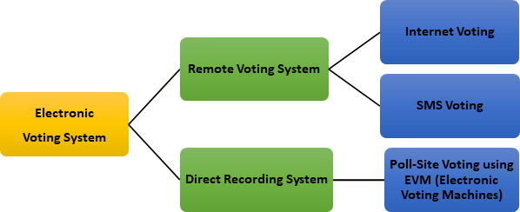

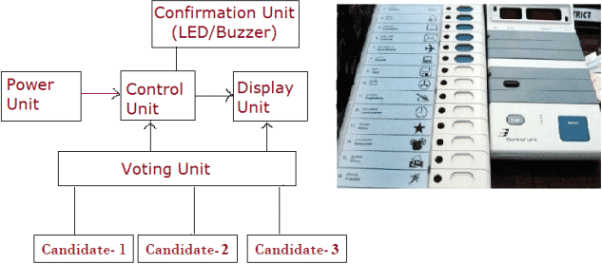

**BLOCK-CHAIN**

The Blockchain Structure is also known as an append-only data structure, such that new blocks of data can be written to it, but cannot be altered or deleted. Private blockchain limits the read and write access, only specific participants can verify their transactions internally. That makes the transaction on a private network cheaper, since they only need to be verified by a few nodes that are trusted and with guaranteed high processing power. Nodes are very well-connected and faults can quickly be fixed by manual intervention, allowing the use of consensus algorithms which offer finality after much shorter block times. In our Research we will use Permissioned Blockchain which will use the Proof of Authority(PoA) consensus Algorithm. A Consensus Algorithm is used to set restrictions on selected known entities to certify and validate Transactions on Blockchain. Here, this will help us to stop adding new People without Administrators Permission. This Algorithm Proves to be Helpful because it does not leak the Voter’s Information and Voting Data.

**Application used for Project:**

1. Metmask Wallet

2. Ganache

3. Remix IDE

4. Solidity

**Module & Team Member wise Distribution of work**

kumar aakarshan (18BCS6640) : All work will be done by kumar aakarshan.

**Innovations in Project**

To Overcome all the Shortcomings in the Present Voting System, we came up with the Modern Technology of Blockchain i.e. E-Voting System using Blockchain. By using this modern technology, following things can be Achieved:- Cheap Voting System, Accurate Voting System, Fast Voting System. Every Citizen desires to have a Transparent and Direct Form of Democracy which is clear cut obtained from this E- Voting System using Blockchain. Faith of People on the Voting System is Increased therefore, many People Come Forward for Voting, thereby Increasing the Percentage of the People Voted. The Pen and the Paper Election is Eradicated thereby creating Accuracy in the Voting System. Everybody Prefers Time ,and Cost Efficient Systems so this E-Voting System using Blockchain is apt for Transparent Democracy. Ethereum Private Blockchain allows hundreds and hundreds of Transactions in a

Second. Utilisation of the Smart Contracts lower the Load on the Blockchain. For Countries with Greater Population, some additional Technology should be added in this E-Voting System using Blockchain to avoid Errors. The main reason behind this system is to present an idea of implementation of blockchain in the voting system.

**Software and Hardware Requirements**

**Application used for Project:**

1. Metmask Wallet

2. Ganache

3. Remix IDE

4. Solidity

**Bibliography:**

1. Github.com
2. Google.com